Running the program
NOTE:
------------------------
To run DataCubeManipulation.pro, you will need
- a folder named maps – Contain unformatted layers for the maps of the planet
- a folder named proc – Contains spectra reduced by Greg Farquhar’s pixel-by-pixel reduction code.
- a folder named spectra – Contains the raw, unreduced spectra
- a folder named formattedMaps – Contains the map layers after limbs have been fitted
- a folder named UMaps – Contains unformatted maps that have been updated (smoothed, corrected, etc)
- a folder named UFormatted – Contains formatted maps that have been updated (smoothed, corrected, etc)
- a folder named guideimg – Contains the processed guide images
- a folder named cal – Contains the calibration files.

IF ANY OF THESE FOLDERS ARE NAMED WRONG, SH*T WILL HIT THE FAN

Spextool itself onlt deals with prism grating type.
Single-order Long and single-Order short are not supported

Copy and paste the following to compile necessary files
.com /home/mziyan/Code/assignGeoCSV
.com /home/mziyan/Code/dataCubeManipulation
.com /home/mziyan/Code/getMu0
.com /home/mziyan/Code/getMuMu0
.com /home/mziyan/Code/getHeaderInfo
.com /home/mziyan/Code/nearest_element
.com /home/mziyan/Code/spexDriver
.com /home/mziyan/Code/viewingLayers
.com /home/mziyan/Code/writeMapHeader
.com /home/mziyan/Code/zmo_drm_ephemeris
.com /home/mziyan/Code/zmo_drm_lcm
.com /home/mziyan/Code/extsespec
.com /home/mziyan/Code/drm_cmap_sam
.com /home/mziyan/Code/zmo_pf_get_mu
.com /home/mziyan/Code/drm_xgeom
.com /home/mziyan/Code/zmo_pf_image_latlon
.com /prvt/glenn2/spitale/drm/programs/Spextool/pro/drm_spextool

-------------------------------
Step 1.

Open up spextools and DRM

Step 2.

Process each guide image. There will be a string of jup.00XXX.a images, and you should look at the image and the header in DRM to make sure the grating type matches the grating type of the spectra you will be reducing. See appendix 1.
Run assignGeoCSV for every processed guide image; put the

Step 3.

Update the paths to the respective directories

Step 4.

Create the Calibration files.

There should be 5 flats followed by an arc. If the files are
flat.00236, flat.00237, flat.00238, flat.00239, flat.00240,
arc.00241, enter in 236 - 241

Step 5.

Click on Spatial Extraction and reduce a single image. (See appendix 2 for more detailed steps)

Under images, if 240.a and 241.b exists, type in 240-241
For the full flat and wavecal name, find the calibrated file.
It should be named something like flat236-240, wavecal241-241
Now click on load Image

When everything is load, click on Guide image and find
the respective guide image.

Put the box on the slit; if the slit is too long vertically,
put it in the middle...

Exit out of the assign geometry window

Click Suggest/Flip Extraction Region

Click 'Go' under Make spatial profiles

Click the large horizontal button 'Extract'

Step 6.

Run createLayers

Input the respective directories and click 'Begin'

If everything goes well (fingers crossed), it will first reduce all the

Step 7.

Format the layers

Click the format button on the right hand side.

You will need to fit limbs several times; it would be total number of
layers divided by 100, rounded up no matter what.

YOU *****MUST***** fit the limbs for the very first (layer 0), and the
layer right before sum.fits. For more accurate limb fittings, you should
look through all the layers beforehand and figure out when the planet stops
/ starts moving (since for some odd reason the planet appears to shift...)

Once you're done fitting the limbs, click format again.

Step 8.

Run ViewingLayers again

Possible Errors
File not found:
Make sure the necessary files are compiled
Make sure the file exists
Check the line of code where it fails to see if you named something wrong

Index error:
Uhhhhh….. send me a screenshot if you can’t fix it…
Likely it’s because you had too many file and somehow matchingSpectraAndGuideImg didn’t process them all

Any other type of error:
Email me at zmo@caltech.edu and moziyan@yahoo.com. If I don’t respond in a few days, add me on Facebook (Ziyan Mo, studies at Caltech and has cover photos of artsy things)…

Features (buttons):
‘Get File’: can only open up sum.fits file. THEY MUST BE IN MAPS FOLDER
‘fit limbs’ : pop-up to fit the limbs so we can get accurate geometric data.
‘change layers’ : input a valid number and press this button to jump to a layer
‘auto-shift’ : supposed to automatically correct the image for you, but does not work at this time. (requires limbs to be fitted on that image)
‘shift manually’: pop-up to move lines of pixels; can shift horizontally or vertically; selected line of pixel are in green.
‘go to sum layer’: goes to the sum layer
‘smooth layer’: requires limb fitting on that layer; will get rid of horizontal striations.
‘format’: click it first, and it will ask user to fit limb 9 ascending images. When finished formatting, click again, and will fit limbs automatically, and output new files.

Appendix

Appendix 1: (copied from Sam Hedge’s report)
  - Determining the appropriate guide image:
    - The guide images are usually taken just prior to the spectral image.
      - However, there were many instances when I could not easily associate each spectral image with its corresponding visible image. I used the .csv file generated from my script to try to figure these out. Supposedly the log book would also be useful, but I had a hard time deciphering it.
      - For each date, I made an excel file with what guide images I thought were associated with what spectral files. To do this, load the spectra into DRM, and after the calibration files are created, go to the Spatial Extraction mode tab. Load up the image normally, and click on Make Spatial Profiles tab. Note where the flux begins to approach background levels. You can change the y-range and consistently note where each spectra with a questionable guide image has the flux fall below a certain level.
        - Then open the potential guide images in DRM by pressing Get Files and selecting the potential guide images. Compare how much of the slit is on the planet in the guide image vs. where the flux drops to the background levels. THIS IS ONLY AN APPROXIMATION, THE TIMES ARE YOUR BEST INDICATION, but I have found it useful.
      - For some dates (July 20th, for instance) the nodding was not done in the typical way DRM is used to dealing with, so it may be best to use a single image for these rather than an AB pair. See images at Appendix for an example.
  - Preparing the guide image
    - From DRM, click on “Get Files”, and select the files you want to use to create the guide image, in AB order
      - Clicking on an image moves it to the selected images pane. Double clicking moves it to the pane and opens it. You can also select multiple images to the selection pane and then click “Browse->Browse All Selected” to view multiple images at once for comparing. Click on an image in the Selections pane to unselect it.
    - If doing an AB subtraction, select the images in AB order, and then click “Edit->Expressions”. In the DRM Expression Handler window that pops up, select “ABAB format subtraction”, and click “OK”. Then click on “Select>Select Updated” to select only the results of the ABAB subtraction. These are the A images of the pair. Unless you save them, they will not overwrite the old A image.
    - For each AB subtracted image:
      - Double click on the AB subtracted A image you prepared, in the Files box
      - Go to “Programs>Preprocessing>Image Tool File”. This uses information from the header file to help with the geometric association.
        - Click “Ok” to use the given values on the pop-up window behind the image.
        - Press Yes to add information to the header
        - Click “No” to not the sort file, as we do not need these images to go in the default DRM file structure
      - Then go to “Edit>Flip” to flip the image to the correct orientation.
      - Go to “Programs>Geometry>Fit Limb” to fit the limb
        - Use the up, down, left, and right arrow keys to adjust the limb. Use the Limb Bigger or Limb Smaller buttons to adjust the size of the limb.
        - To assist in the fitting, you can go to “Edit>Expression” and try typing in “a>0” or restrict the values of the pixel to a certain range, i.e. “100>a>10” or hist_equal(a). Be sure to go to “Edit>Undo” before you click on “Done” to undo the expression you entered.
      - Click on “Done-No Optimize”
Comment: The Optimize option has not been working right for me
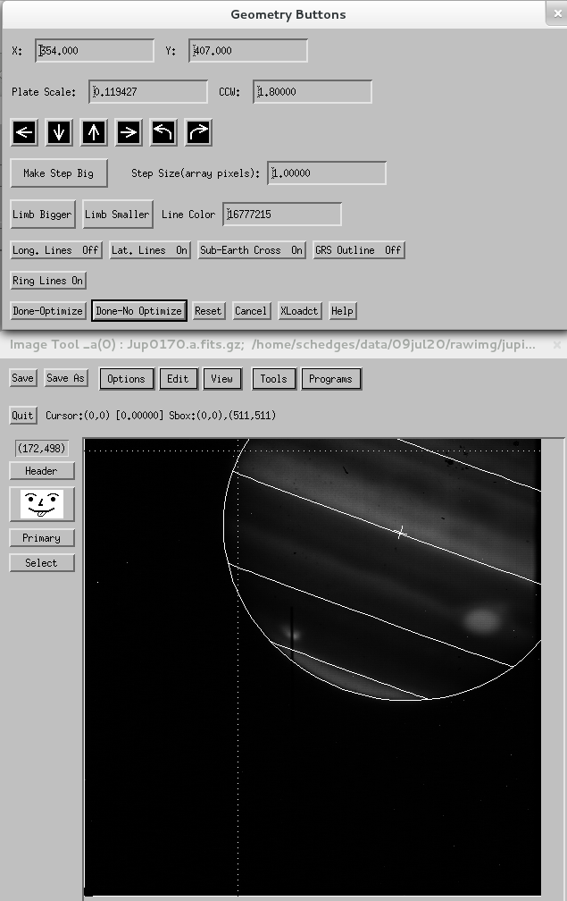

Figure 13. Assigning geometry to the guide image in DRM
      - Then go to “Programs>Photometry>Disk Aperture Photometry”, and click “Yes” to update the header file
        - A pop-up window will open behind the image
      - Go to “Save As”. The standard naming scheme I have been using is “jupguide#_#” for AB image pairs, and “jupguide#” for single A or B images. I have been saving the guide images in the cal folder
      - Click on “Quit” not the “x” in the corner to close, as this can freeze DRM. Your guide image is now ready for the Spatial Extraction routine.

Appendix 2: (copied from Sam Hedge’s report)
Comment: This routine was written by Greg Farquhar in 2013 to extract the spectra of extended sources on a pixel-by-pixel basis. This routine allows many more apertures than the default by the Spextool extended source option, and assigns the spectra to a geometric location on the planet based on a guide image associated with each spectrum. To learn more about preparing the guide images, see that section.
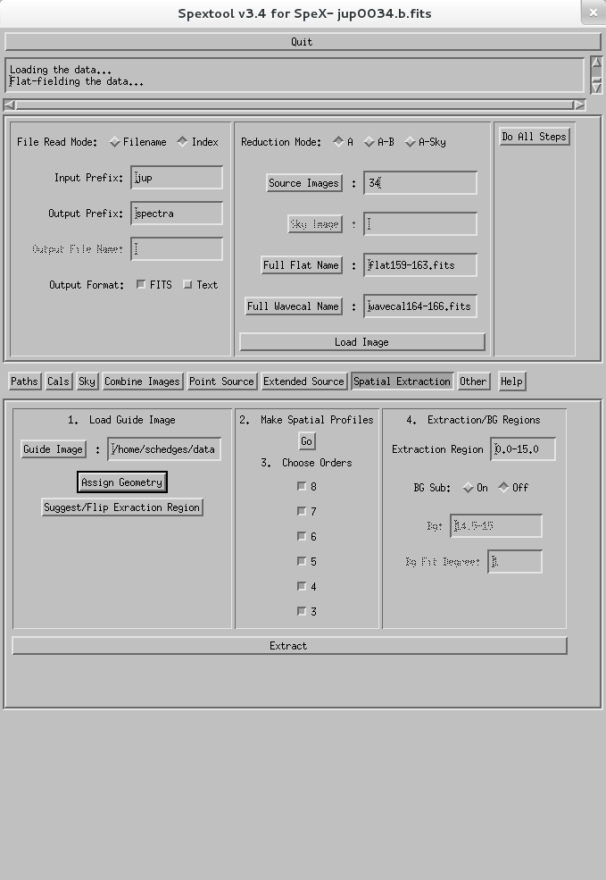

Figure 14. The Spatial Extraction base
  - Click on the “Spatial Extraction” tab to bring up the Spatial Extraction base
  - In the File Read Mode base:
    - Adjust the Input Prefix (typically “jup”) and Output Prefix (typically spectra).
  - The Load Image base:
    - For Reduction Mode choose either A, AB, or A-Sky mode.
    - For Source Image type in the numbers corresponding to the source images you want to use, i.e. for AB mode with files jup0001.a.fits and jup0002.b.fits make sure the prefix is “jup” and enter 1-2
      - You can also change the File Read Mode to Filename and then press the Source Images button and select the images that way
    - Press the Full Flat Name and Full Wavecal Name buttons to select the calibration files.
    - Click “Load Image”
      - DO NOT exit the window that pops up before the extraction is complete, doing so will cause Spextool to freeze later.
  - The Load Guide Image base:
    - Click on “Guide Image” and navigate to the location of the guide image you prepared
    - Click “Assign Geometry”
      - Click the pointer near the black rectangle on the guide image indicating the slit. Use the arrow keys for accurate tuning of the white box on the slit location
      - NOTE: I added code to Greg's routine to store the coordinates where the user saves the slit
      - Press “Done”
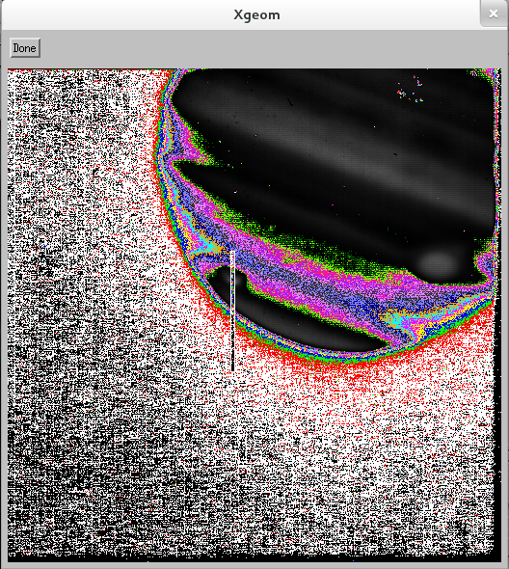

Figure 15. Assigning location to the slit with Spextool—the colors are not normally weird like this
    - Then click “Suggest/Flip Extraction Region”
  - The Make Spatial Profiles base:
    - Click “Go” in the Make Spatial Profiles base
      - DO NOT close this window, or you will get an error
  - Extraction/BG Regions base:
    - Check that the region in the spatial profile where the flux drops off (goes to the background level) is approximately the range in the “Extraction Region” box. If it is completely off, click on the “Suggest/Flip Extraction Region” button in the Load Guide Image base to switch the regions
      - DO NOT manually increase the extraction region, as you can extend it off of the planet, which will lead to a lot of errors layer on
    - If you see the background (i.e. an area where the slit becomes flat), turn BG Sub on and set the background region
      - Set the fit to 0 for a horizontal line (recommended)
  - Click “Extract” to extract the spectra
  - Press Done on the pop-up window.
  - If other spectra use the same guide image, you can now replace the Source Image text with the rest of the spectra using that guide image, and then press Do All Steps
    - Spectra that use the same guide image may be able to be combined using xcombspec. This is also a good way to check that all spectra truly used the same guide image. If one is significantly different than the others, it probably was taken at a different place and should use a different guide image.

